CENTRAL OKLAHOMA MASTER CONSERVANCY DISTRICT  AGENDA FOR REGULAR MEETING  Thursday, November 2, 2023  6:30 P.M.  Kyle Arthur, General Manager  12500 Alameda Dr  Norman, OK 73026 | 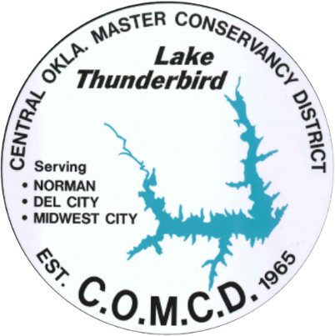

To accommodate the public, including presenters of agenda items, who wish to participate but not to attend the meeting in person, videoconference and teleconference capability is being made available, but videoconference and teleconference connections and quality of connections are outside the control of the District and cannot be assured. Although this accommodation is provided, members of the public including presenters are welcome to attend the meeting in-person.

To participate and listen to the meeting by telephone, call 1-866-899-4679, Access Code: 689-27-0941.
To participate and listen via a computer, smartphone, or tablet, go to https://meet.goto.com/689270941.

Board meeting packet can be found on website: https://comcd.net. This agenda was posted in the notice enclosure outside the COMCD office gate at 9:00 AM on Friday, October 27, 2023.
A. Call to order and roll call
B. Statement of compliance with Open Meeting Act
C. Administrative
1. Public comment
This is an opportunity for the public to address the COMCD board. Due to Open Meeting Act regulations, board members are not able to participate in discussion during this comment period. Comments will be accepted from those persons attending in-person and through the virtual meeting option. You are required to sign-up in advance of the meeting in order to be eligible to make comment. You may sign-up by calling the COMCD office at 405-329-5228 during regular business hours (8:00 AM – 4:30 PM) or by contacting the office via email at admin@comcd.net. Public comment sign-up will end at 12:00 PM (noon) CDT on Thursday, November 2, 2023. Any request received after that will not be eligible. When signing up, you must provide your name, city of residence and topic about which you wish to speak. Each commenter will be limited to three minutes and the entire comment period will not exceed one hour. Eligible commenters will be called to address the board in the order in which their request was received. Given the one-hour time limit, not all commenters are guaranteed the opportunity to speak. Written comments will also be accepted and kept as a matter of record for the meeting. If all commenters have addressed the board prior to the one-hour time limit, the public comment agenda item will be closed, and the balance of the time yielded back to the remainder of the agenda. The President reserves discretion during the meeting to make an adjustment to the public comment schedule.
2. Presentation from Oklahoma Tourism and Recreation Department
3. Treasurer Report- September 2023 financials
D. Action:
Pursuant to 82 Okla. Statutes, Section 541 (D) (10), the Board of Directors shall perform official actions by Resolution and all official actions including final passage and enactment of all Resolutions must be present at a regular or special meeting. The following items may be discussed, considered, and approved, disapproved, amended, tabled or other action taken:
4. Minutes of the regular board meeting held on Thursday, October 5, 2023, and corresponding Resolution
E. Discussion
5. Legal Counsel’s Report
6. General Manager’s Report
7. President’s Report
8. New business (any matter not known prior to the meeting, and which could not have been reasonably foreseen prior to the posting of the Agenda)
F. Adjourn

